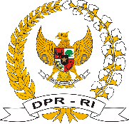 | 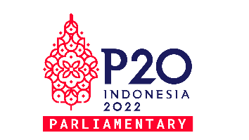  Parliamentary Forum and  ｖ  the Eighth G20 Parliamentary Speakers’ Summit (P20)  5 – 7 October 2022  Hotel Booking Form | 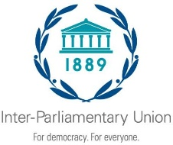
PLEASE COMPLETE THIS FORM AND SEND IT DIRECTLY TO THE CHOOSEN HOTEL

Parliament / Organization: Enter
Name of the Hotel: Select

Title / Affix. | Last name | First name | Position | Hotel Booking | Itinerary | Date | Time | Flight Number
Select | Enter | Enter | Enter | Check-in | Arrival | Select | Enter | Enter
 |  |  |  | Check-out | Departure | Select | Enter | Enter
Select | Enter | Enter | Enter | Check-in | Arrival | Select | Enter | Enter
 |  |  |  | Check-out | Departure | Select | Enter | Enter
Select | Enter | Enter | Enter | Check-in | Arrival | Select | Enter | Enter
 |  |  |  | Check-out | Departure | Select | Enter | Enter
Select | Enter | Enter | Enter | Check-in | Arrival | Select | Enter | Enter
 |  |  |  | Check-out | Departure | Select | Enter | Enter
Select | Enter | Enter | Enter | Check-in | Arrival | Select | Enter | Enter
 |  |  |  | Check-out | Departure | Select | Enter | Enter

Sent by
Name : Enter
Title : Enter
Telephone : Enter Email : Enter
*The hotel e-mail address is available at the general information
*The Indonesian Parliament will provide transportation service from the airport to the hotels and from the hotels to the venue.

